**Goals:** The goal is to visualize and understand the average age of FIFA 2022 female players across the globe.

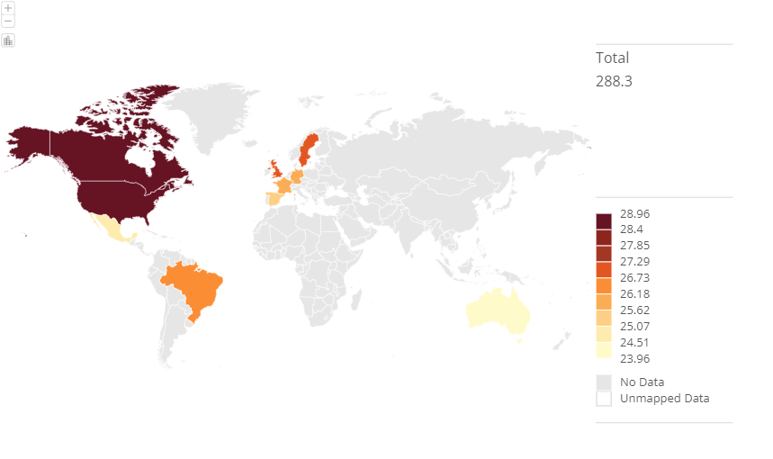

(image)

**Insight:** This geographic world map visualizer provides the insights on countries with high or low average ages for FIFA 2022 female players. Based on the above visualization we can say that America and   
Canada has the highest average age for female FIFA players in the year 2022 which was around 28 years old. Whereas countries like Australia, China PR, and Mexico had the lowest average age which was around 24 years old, this shows that these countries are promoting the young female football talents in their regions. With the help of this insights, we can predict the retirement age for female football players, development program for young talents length of their professional career.

**Data abstraction:** With the use of Domo, I have made this visualization and below are the details about the data:

* **Dataset type:** Tabular data (in excel file) shown with geographic map.
  + Item: Country wise average age of the players.
  + Attributes:
    - nationality_name
    - age

**Task abstraction:**

**Marks:** Countries shown on the map

**Channels:** Color represents the average age

**Users:** The possible users for this visualizations will be analysts who are interested in FIFA women’s football demographics.

**Targets:** The possible targets for this visualization will be local coaches who are training the young footballer, they can look into this and work on their players accordingly.

**Actions:** Action here will be exploring and comparing the data, and identifying the pattern between the countries based on the average age of the players.

**Additional data source:** This visualization has been developed on Domo (<https://swansea-ac-uk-280.domo.com/>) and dataset for this is[**https://www.kaggle.com/datasets/stefanoleone992/fifa-22-complete-player-dataset/data**](https://www.kaggle.com/datasets/stefanoleone992/fifa-22-complete-player-dataset/data)